**EE443: Digital Image Processing**

**Lab No. #01: Introduction to Python**

# Task One:

## Code:

|  |
| --- |
| def add(a, b):      "Return the sum of a and b"      print "Passed a=%s and b=%s, returning a+b=%s" % (a,b,a+b)      return a+b |

## Output:

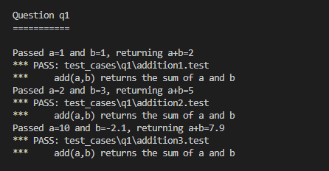

# Task Two:

## Code:

|  |
| --- |
| fruitPrices = {'apples':2.00, 'oranges': 1.50, 'pears': 1.75,                'limes':0.75, 'strawberries':1.00}  def buyLotsOfFruit(orderList):        totalCost = 0.0      i = 0      for x in orderList:          fruitName = orderList[i][0]          if fruitName in fruitPrices:              fruitCost = fruitPrices[fruitName] * orderList[i][1]              totalCost = totalCost + fruitCost              i = i + 1      return totalCost  # Main Method  if __name__ == '__main__':      "This code runs when you invoke the script from the command line"      orderList = [ ('apples', 2.0), ('pears', 3.0), ('limes', 4.0) ]      print 'Cost of', orderList, 'is', buyLotsOfFruit(orderList) |

## Output:



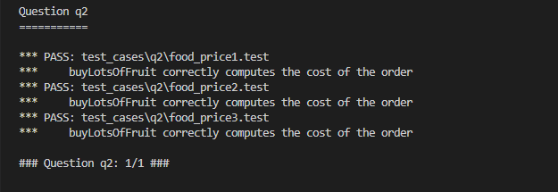

# Task Three:

## Code:

|  |
| --- |
| def shopSmart(orderList, fruitShops):      """          orderList: List of (fruit, numPound) tuples          fruitShops: List of FruitShops      """      i = 0      smallest = 999999      smallestindex = 0      costsForDifferentShops = []      for x in fruitShops:          cost = x.getPriceOfOrder(orderList)          costsForDifferentShops.append(cost)      for j in costsForDifferentShops:          if j < smallest:              smallest = j              smallestindex = i          i = i + 1      return fruitShops[smallestindex]  if __name__ == '__main__':    "This code runs when you invoke the script from the command line"    orders = [('apples',1.0), ('oranges',3.0)]    dir1 = {'apples': 2.0, 'oranges':1.0}    shop1 =  shop.FruitShop('shop1',dir1)    dir2 = {'apples': 1.0, 'oranges': 5.0}    shop2 = shop.FruitShop('shop2',dir2)    shops = [shop1, shop2]    print "For orders ", orders, ", the best shop is", shopSmart(orders, shops).getName()    orders = [('apples',3.0)]    print "For orders: ", orders, ", the best shop is", shopSmart(orders, shops).getName() |

## Output

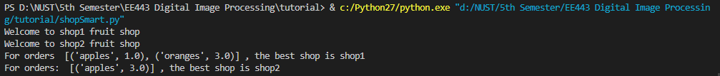

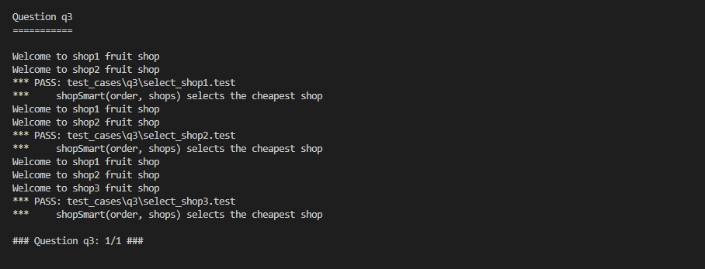

# Task Four:

Write a program to remove a specific character from a string using Python. Your code should be able to take string and index (index of the character to be removed) as input and display the output string with removed characters from mentioned index.

## Code:

|  |
| --- |
| word = input('Enter your word: ')  index = input('Enter the index number you want to remove: ')  newWord = ''  if int(index) >= len(word): #index starts from 0, so possible index values are from 0 to len(word) - 1      print('This index does not exist')  else:      for i in range(len(word)):          if i != int(index):              newWord = newWord + word[i]      print(newWord) |

## Output:

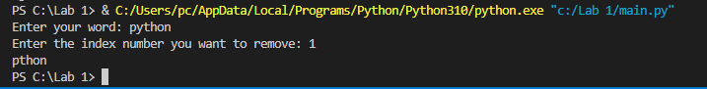

# Task Five:

Write a program in Python to calculate the time elapsed to execute the code. You may calculate the elapsed time of any of the task you have performed in this lab. But please specify the full piece of code in your lab report.

## Code

|  |
| --- |
| from datetime import datetime  time1 = datetime.now()  word = input('Enter your word: ')  index = input('Enter the index number you want to remove: ')  newWord = ''  if int(index) >= len(word): #index starts from 0, so possible index values are from 0 to len(word) - 1      print('This index does not exist')  else:      for i in range(len(word)):          if i != int(index):              newWord = newWord + word[i]      print(newWord)  time2 = datetime.now()  timetaken = time2-time1  print('Time taken to execute this program is ', timetaken) |

## Output

